AI CODING LAB 12.4
NAME: Sharikha Imtiaz Khan
ROLLNO:2403A52368
Task1: Write a Python implementation of Bubble Sort
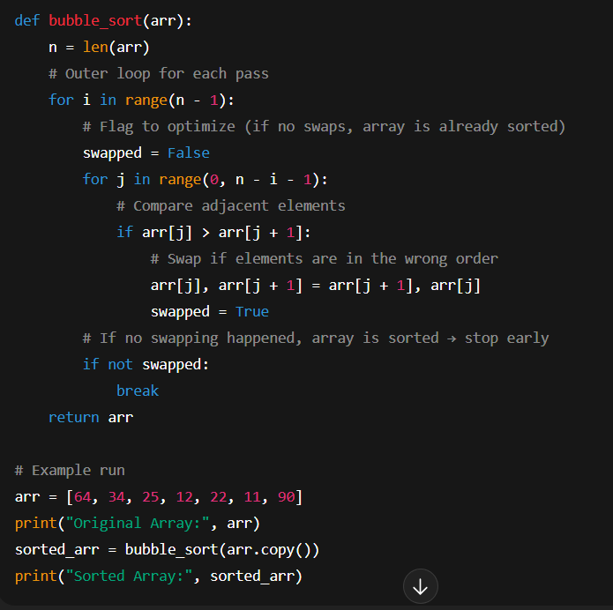
Output:
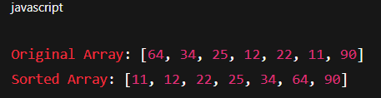
Task2: Provide Bubble Sort code to AI and ask it to suggest a more efficient algorithm for partially sorted arrays.
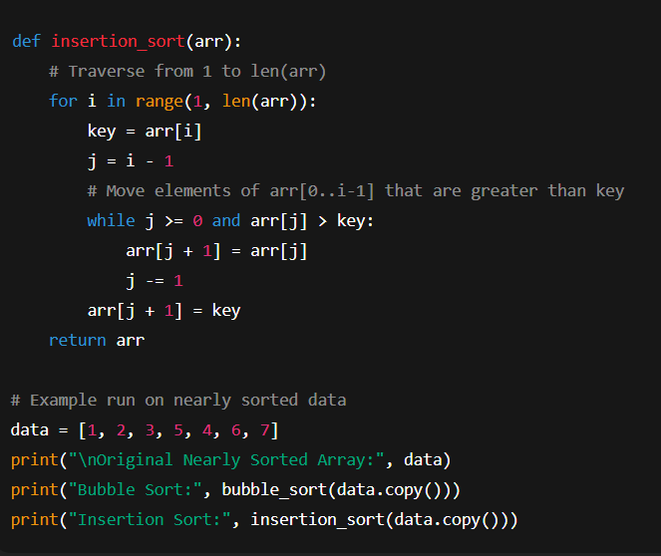
Output:
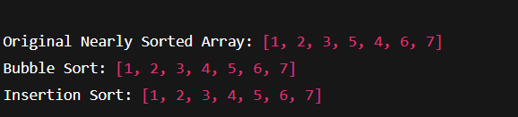

Task3: Implement both Linear Search and Binary Search
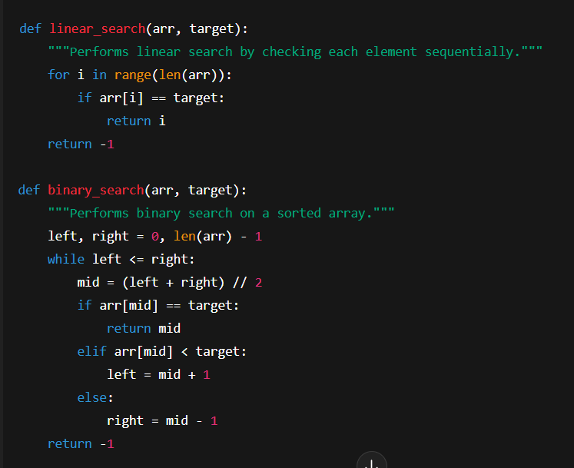
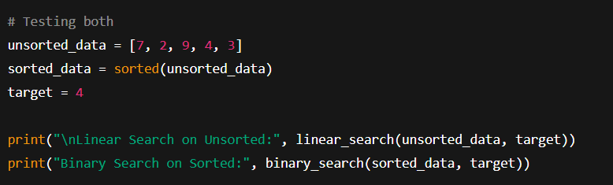
Output:
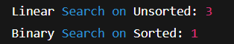
Task4: Implement Quick Sort and Merge Sort using recursion
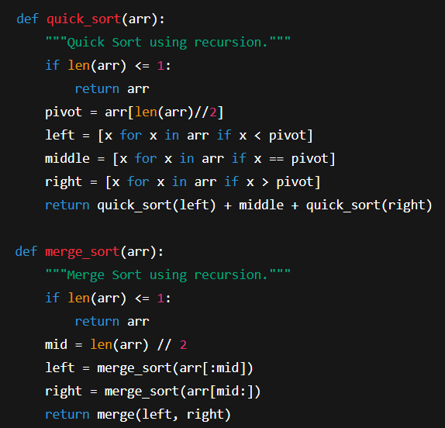
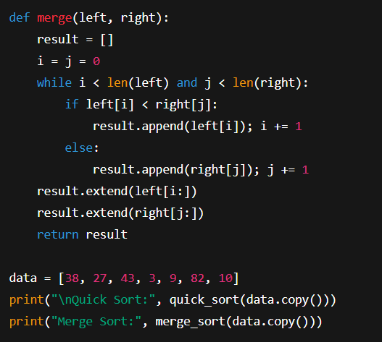
Output:
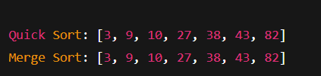
Task5: Give AI a naive algorithm (e.g., O(n²) duplicate search).
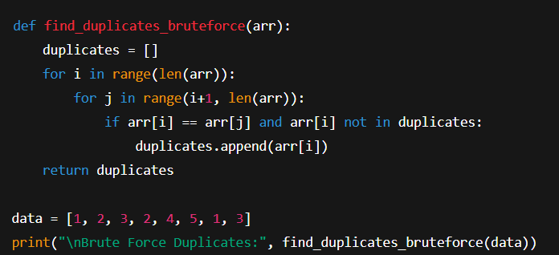
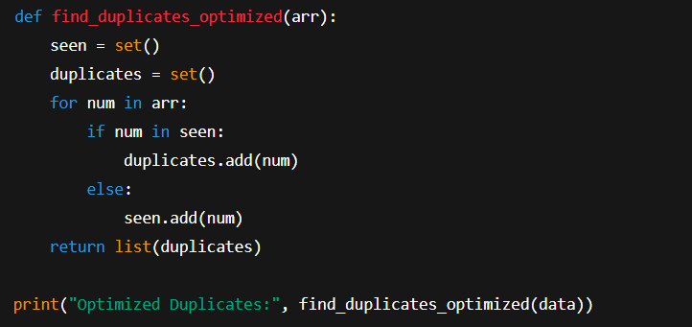
Output:
